**Pictures**

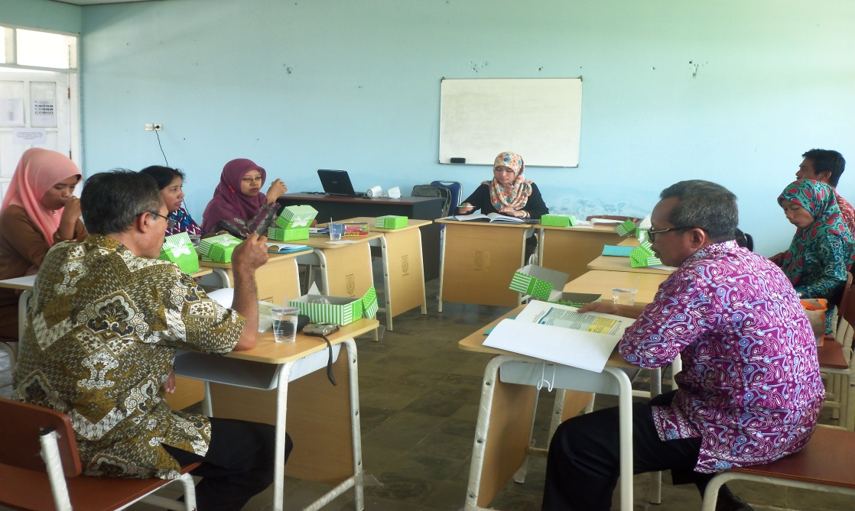

**1**

Focus Group Discussion

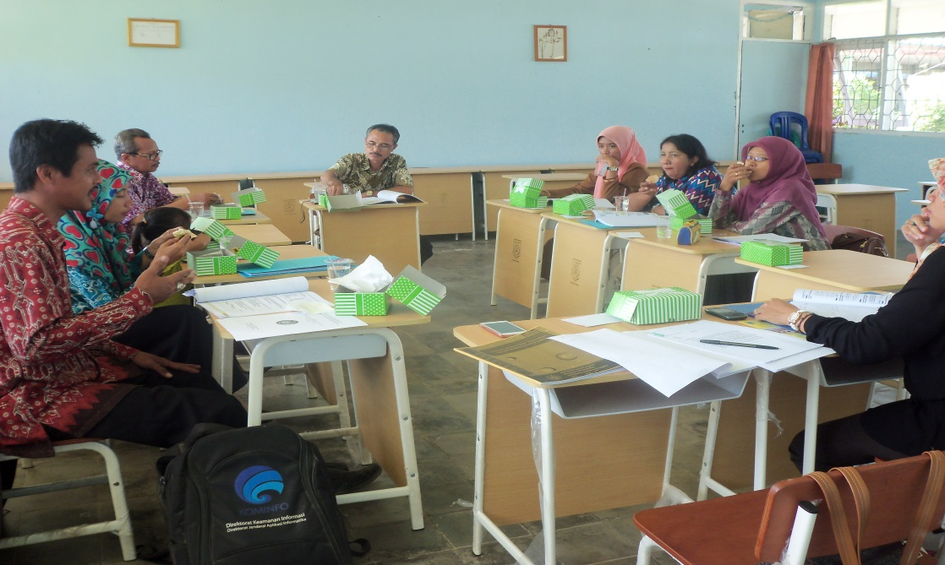

**2**

Focus Group Discussion

**3**

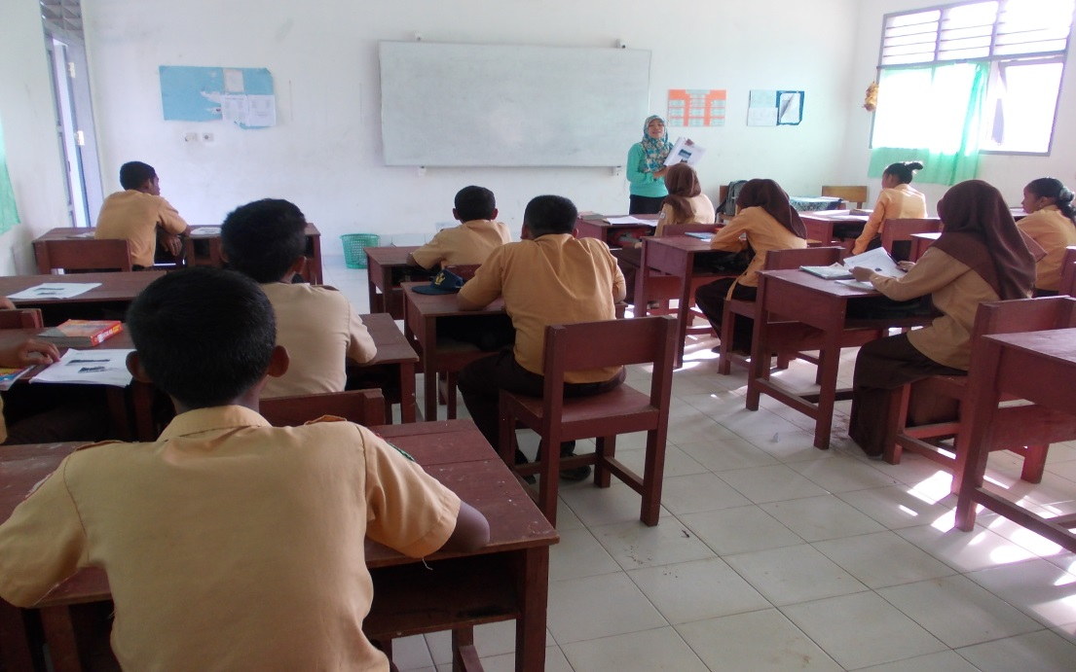

classroom activity

**4**

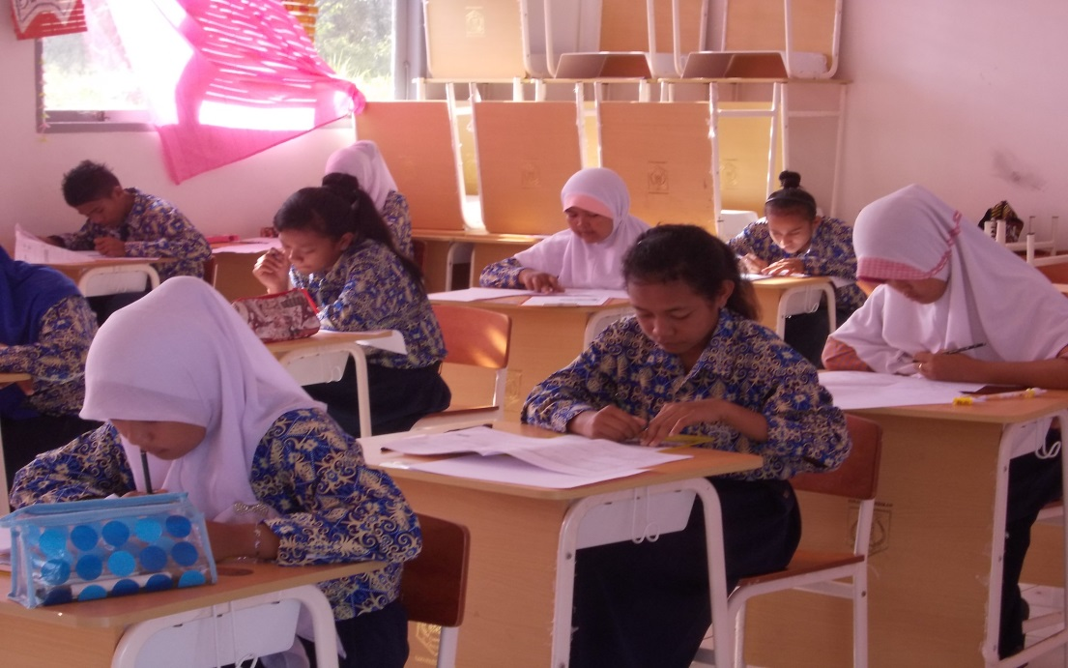

classroom activity

**5**

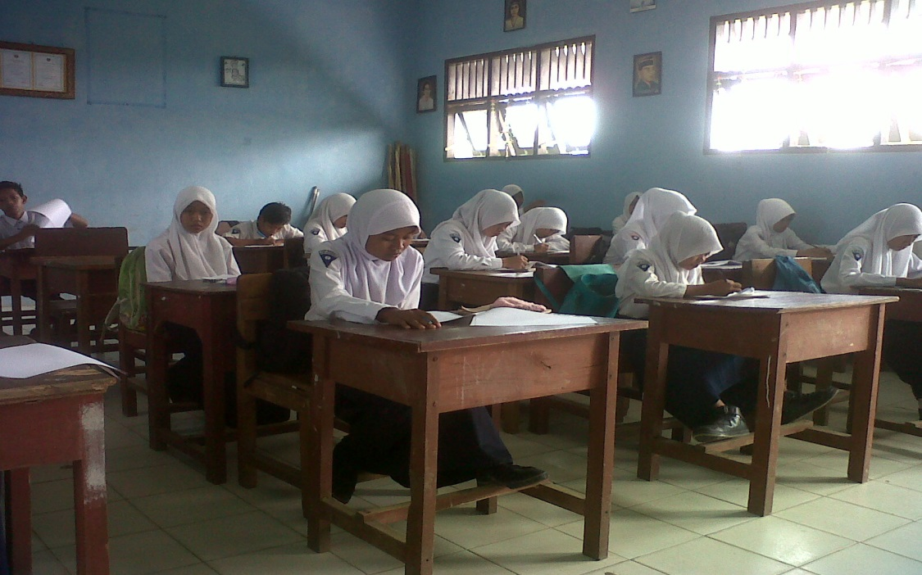

classroom activity

**6**

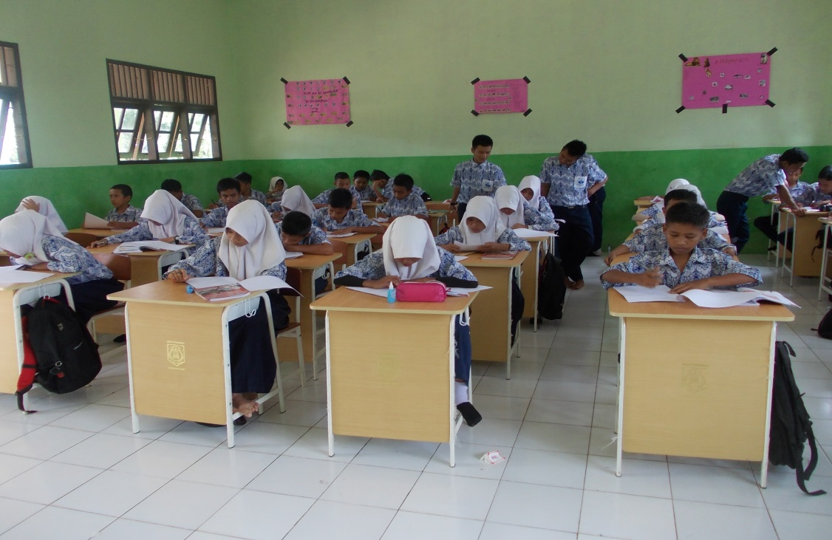

classroom activity

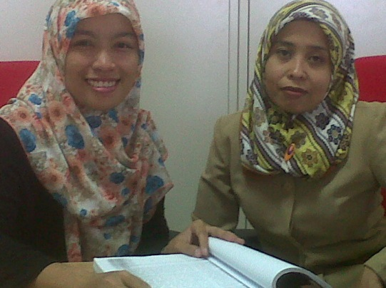

**7**

The researcher and a local culture expert in the department of culture.

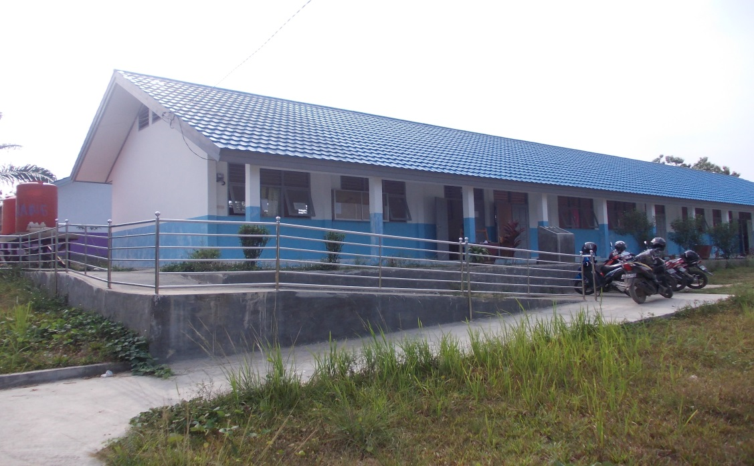

**8**

One of the schools in Pasir Belengkong Sub district