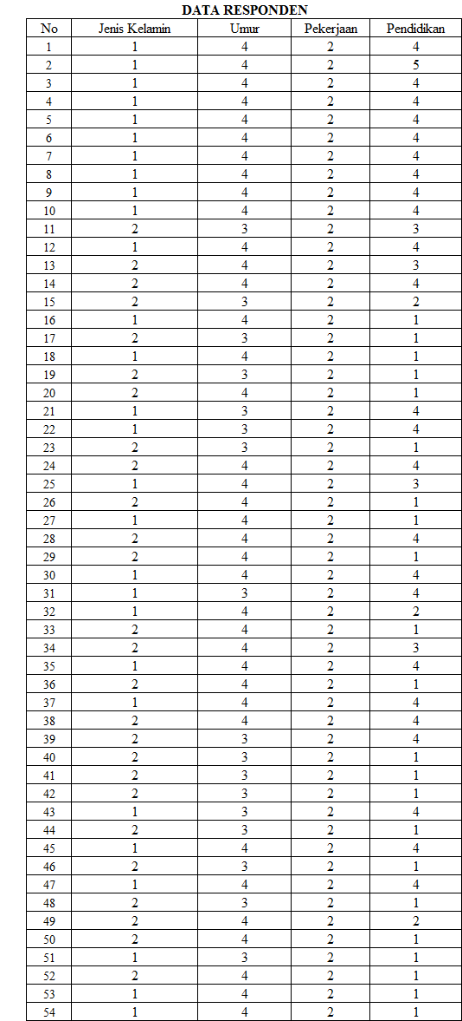

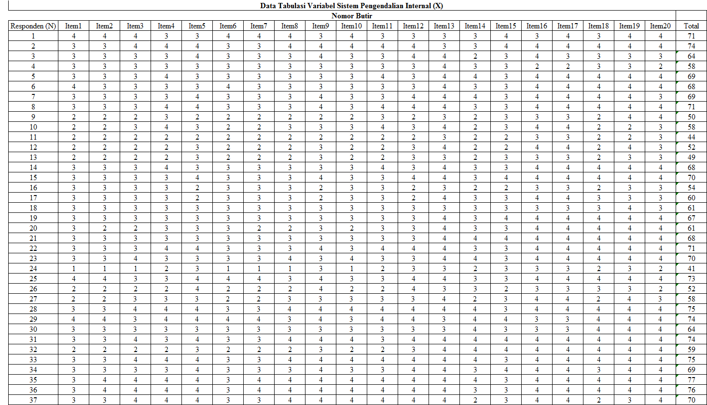

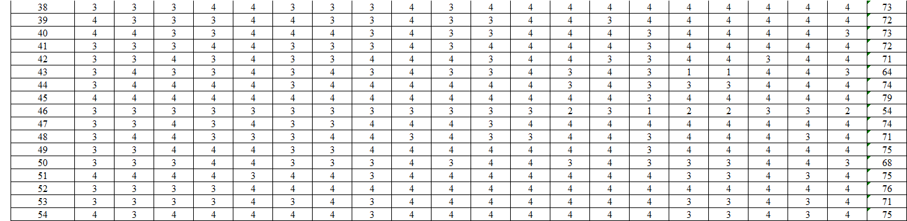

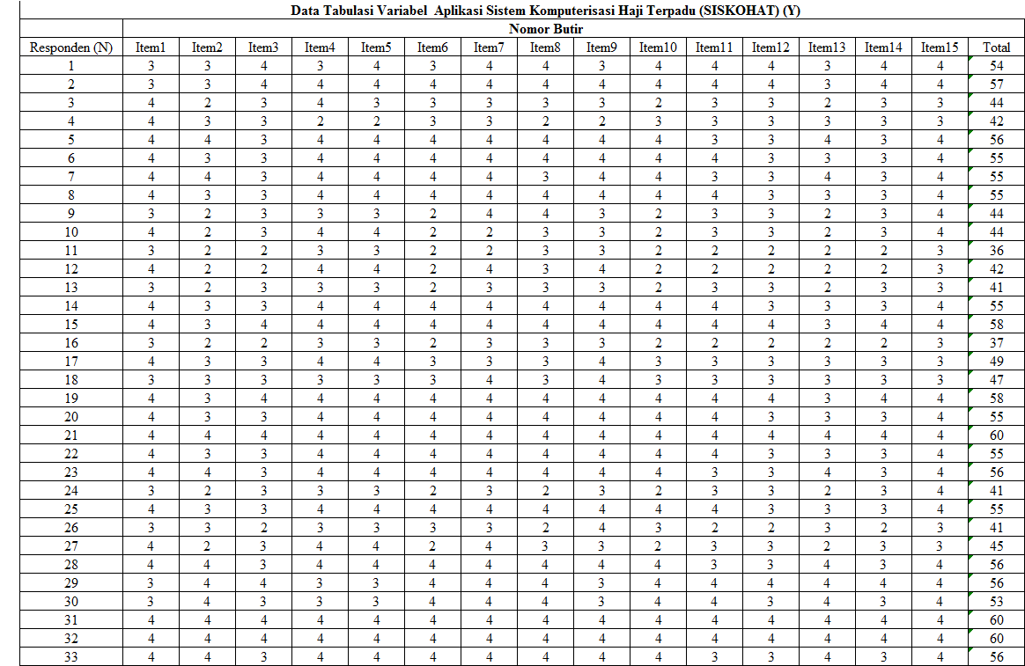

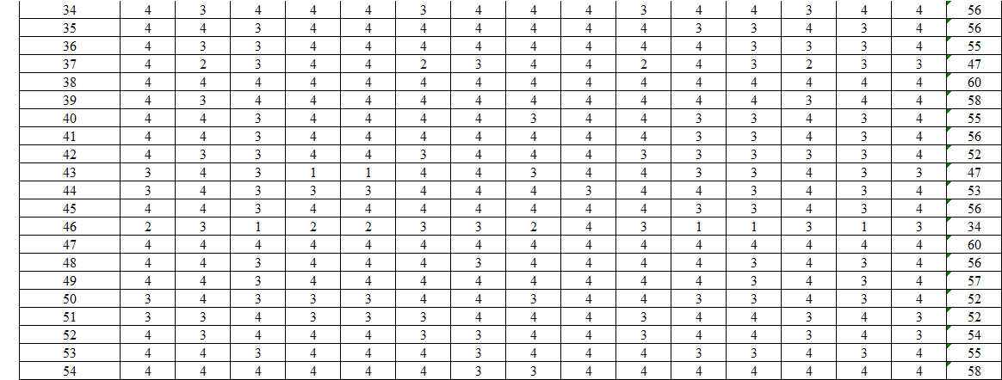

**Tabel Correlations Sistem Pengendalian Internal**

|  |  |  |  |  |  |  |  |  |  |  |  |  |  |  |  |  |  |  |  |  |  |  |
| --- | --- | --- | --- | --- | --- | --- | --- | --- | --- | --- | --- | --- | --- | --- | --- | --- | --- | --- | --- | --- | --- | --- |
|  | | Item1 | Item2 | Item3 | Item4 | Item5 | Item6 | Item7 | Item8 | Item9 | Item10 | Item11 | Item12 | Item13 | Item14 | Item15 | Item16 | Item17 | Item18 | Item19 | Item20 | Total |
| Item1 | Pearson Correlation | 1 | .802** | .596** | .474** | .352** | .977** | .803** | .518** | .400** | .584** | .466** | .400** | .222 | .483** | .333* | .072 | .118 | .603** | .314* | .460** | .739** |
| Sig. (2-tailed) |  | .000 | .000 | .000 | .009 | .000 | .000 | .000 | .003 | .000 | .000 | .003 | .107 | .000 | .014 | .603 | .396 | .000 | .021 | .000 | .000 |
| N | 54 | 54 | 54 | 54 | 54 | 54 | 54 | 54 | 54 | 54 | 54 | 54 | 54 | 54 | 54 | 54 | 54 | 54 | 54 | 54 | 54 |
| Item2 | Pearson Correlation | .802** | 1 | .710** | .518** | .396** | .783** | .946** | .679** | .440** | .693** | .508** | .440** | .112 | .551** | .217 | -.043 | .000 | .582** | .310* | .402** | .751** |
| Sig. (2-tailed) | .000 |  | .000 | .000 | .003 | .000 | .000 | .000 | .001 | .000 | .000 | .001 | .420 | .000 | .115 | .760 | 1.000 | .000 | .023 | .003 | .000 |
| N | 54 | 54 | 54 | 54 | 54 | 54 | 54 | 54 | 54 | 54 | 54 | 54 | 54 | 54 | 54 | 54 | 54 | 54 | 54 | 54 | 54 |
| Item3 | Pearson Correlation | .596** | .710** | 1 | .650** | .423** | .576** | .692** | .944** | .458** | .965** | .626** | .458** | .285* | .479** | .267 | .212 | .252 | .447** | .221 | .512** | .803** |
| Sig. (2-tailed) | .000 | .000 |  | .000 | .001 | .000 | .000 | .000 | .000 | .000 | .000 | .000 | .037 | .000 | .051 | .125 | .066 | .001 | .109 | .000 | .000 |
| N | 54 | 54 | 54 | 54 | 54 | 54 | 54 | 54 | 54 | 54 | 54 | 54 | 54 | 54 | 54 | 54 | 54 | 54 | 54 | 54 | 54 |
| Item4 | Pearson Correlation | .474** | .518** | .650** | 1 | .422** | .451** | .499** | .587** | .456** | .614** | .958** | .456** | .241 | .385** | .198 | .207 | .207 | .452** | .236 | .484** | .702** |
| Sig. (2-tailed) | .000 | .000 | .000 |  | .001 | .001 | .000 | .000 | .001 | .000 | .000 | .001 | .079 | .004 | .151 | .133 | .133 | .001 | .086 | .000 | .000 |
| N | 54 | 54 | 54 | 54 | 54 | 54 | 54 | 54 | 54 | 54 | 54 | 54 | 54 | 54 | 54 | 54 | 54 | 54 | 54 | 54 | 54 |
| Item5 | Pearson Correlation | .352** | .396** | .423** | .422** | 1 | .368** | .440** | .449** | .977** | .455** | .461** | .977** | .279* | .458** | .329* | .206 | .161 | .538** | .392** | .289* | .686** |
| Sig. (2-tailed) | .009 | .003 | .001 | .001 |  | .006 | .001 | .001 | .000 | .001 | .000 | .000 | .041 | .001 | .015 | .134 | .243 | .000 | .003 | .034 | .000 |
| N | 54 | 54 | 54 | 54 | 54 | 54 | 54 | 54 | 54 | 54 | 54 | 54 | 54 | 54 | 54 | 54 | 54 | 54 | 54 | 54 | 54 |
| Item6 | Pearson Correlation | .977** | .783** | .576** | .451** | .368** | 1 | .823** | .543** | .414** | .603** | .486** | .414** | .234 | .499** | .362** | .089 | .133 | .608** | .323* | .467** | .752** |
| Sig. (2-tailed) | .000 | .000 | .000 | .001 | .006 |  | .000 | .000 | .002 | .000 | .000 | .002 | .088 | .000 | .007 | .523 | .337 | .000 | .017 | .000 | .000 |
| N | 54 | 54 | 54 | 54 | 54 | 54 | 54 | 54 | 54 | 54 | 54 | 54 | 54 | 54 | 54 | 54 | 54 | 54 | 54 | 54 | 54 |
| Item7 | Pearson Correlation | .803** | .946** | .692** | .499** | .440** | .823** | 1 | .666** | .479** | .744** | .565** | .479** | .153 | .597** | .305* | -.072 | -.031 | .602** | .241 | .430** | .775** |
| Sig. (2-tailed) | .000 | .000 | .000 | .000 | .001 | .000 |  | .000 | .000 | .000 | .000 | .000 | .269 | .000 | .025 | .607 | .822 | .000 | .079 | .001 | .000 |
| N | 54 | 54 | 54 | 54 | 54 | 54 | 54 | 54 | 54 | 54 | 54 | 54 | 54 | 54 | 54 | 54 | 54 | 54 | 54 | 54 | 54 |
| Item8 | Pearson Correlation | .518** | .679** | .944** | .587** | .449** | .543** | .666** | 1 | .443** | .948** | .606** | .443** | .273* | .460** | .237 | .279* | .320* | .436** | .307* | .503** | .793** |
| Sig. (2-tailed) | .000 | .000 | .000 | .000 | .001 | .000 | .000 |  | .001 | .000 | .000 | .001 | .046 | .000 | .084 | .041 | .018 | .001 | .024 | .000 | .000 |
| N | 54 | 54 | 54 | 54 | 54 | 54 | 54 | 54 | 54 | 54 | 54 | 54 | 54 | 54 | 54 | 54 | 54 | 54 | 54 | 54 | 54 |
| Item9 | Pearson Correlation | .400** | .440** | .458** | .456** | .977** | .414** | .479** | .443** | 1 | .488** | .492** | 1.000** | .296* | .485** | .367** | .180 | .135 | .557** | .354** | .307* | .713** |
| Sig. (2-tailed) | .003 | .001 | .000 | .001 | .000 | .002 | .000 | .001 |  | .000 | .000 | .000 | .030 | .000 | .006 | .193 | .331 | .000 | .009 | .024 | .000 |
| N | 54 | 54 | 54 | 54 | 54 | 54 | 54 | 54 | 54 | 54 | 54 | 54 | 54 | 54 | 54 | 54 | 54 | 54 | 54 | 54 | 54 |
| Item10 | Pearson Correlation | .584** | .693** | .965** | .614** | .455** | .603** | .744** | .948** | .488** | 1 | .666** | .488** | .309* | .517** | .326* | .199 | .239 | .470** | .198 | .532** | .823** |
| Sig. (2-tailed) | .000 | .000 | .000 | .000 | .001 | .000 | .000 | .000 | .000 |  | .000 | .000 | .023 | .000 | .016 | .149 | .082 | .000 | .152 | .000 | .000 |
| N | 54 | 54 | 54 | 54 | 54 | 54 | 54 | 54 | 54 | 54 | 54 | 54 | 54 | 54 | 54 | 54 | 54 | 54 | 54 | 54 | 54 |
| Item11 | Pearson Correlation | .466** | .508** | .626** | .958** | .461** | .486** | .565** | .606** | .492** | .666** | 1 | .492** | .270* | .432** | .266 | .195 | .195 | .480** | .212 | .510** | .732** |
| Sig. (2-tailed) | .000 | .000 | .000 | .000 | .000 | .000 | .000 | .000 | .000 | .000 |  | .000 | .048 | .001 | .052 | .157 | .157 | .000 | .125 | .000 | .000 |
| N | 54 | 54 | 54 | 54 | 54 | 54 | 54 | 54 | 54 | 54 | 54 | 54 | 54 | 54 | 54 | 54 | 54 | 54 | 54 | 54 | 54 |
| Item12 | Pearson Correlation | .400** | .440** | .458** | .456** | .977** | .414** | .479** | .443** | 1.000* | .488** | .492** | 1 | .296* | .485** | .367** | .180 | .135 | .557** | .354** | .307* | .713** |
| Sig. (2-tailed) | .003 | .001 | .000 | .001 | .000 | .002 | .000 | .001 | .000 | .000 | .000 |  | .030 | .000 | .006 | .193 | .331 | .000 | .009 | .024 | .000 |
| N | 54 | 54 | 54 | 54 | 54 | 54 | 54 | 54 | 54 | 54 | 54 | 54 | 54 | 54 | 54 | 54 | 54 | 54 | 54 | 54 | 54 |
| Item13 | Pearson Correlation | .222 | .112 | .285* | .241 | .279* | .234 | .153 | .273* | .296* | .309* | .270* | .296* | 1 | .220 | .406** | .714** | .657** | .343* | .206 | .468** | .497** |
| Sig. (2-tailed) | .107 | .420 | .037 | .079 | .041 | .088 | .269 | .046 | .030 | .023 | .048 | .030 |  | .110 | .002 | .000 | .000 | .011 | .136 | .000 | .000 |
| N | 54 | 54 | 54 | 54 | 54 | 54 | 54 | 54 | 54 | 54 | 54 | 54 | 54 | 54 | 54 | 54 | 54 | 54 | 54 | 54 | 54 |
| Item14 | Pearson Correlation | .483** | .551** | .479** | .385** | .458** | .499** | .597** | .460** | .485** | .517** | .432** | .485** | .220 | 1 | .391** | .042 | .079 | .850** | .443** | .427** | .695** |
| Sig. (2-tailed) | .000 | .000 | .000 | .004 | .001 | .000 | .000 | .000 | .000 | .000 | .001 | .000 | .110 |  | .003 | .765 | .569 | .000 | .001 | .001 | .000 |
| N | 54 | 54 | 54 | 54 | 54 | 54 | 54 | 54 | 54 | 54 | 54 | 54 | 54 | 54 | 54 | 54 | 54 | 54 | 54 | 54 | 54 |
| Item15 | Pearson Correlation | .333* | .217 | .267 | .198 | .329* | .362** | .305* | .237 | .367** | .326* | .266 | .367** | .406** | .391** | 1 | .269* | .313* | .454** | .330* | .600** | .534** |
| Sig. (2-tailed) | .014 | .115 | .051 | .151 | .015 | .007 | .025 | .084 | .006 | .016 | .052 | .006 | .002 | .003 |  | .049 | .021 | .001 | .015 | .000 | .000 |
| N | 54 | 54 | 54 | 54 | 54 | 54 | 54 | 54 | 54 | 54 | 54 | 54 | 54 | 54 | 54 | 54 | 54 | 54 | 54 | 54 | 54 |
| Item16 | Pearson Correlation | .072 | -.043 | .212 | .207 | .206 | .089 | -.072 | .279* | .180 | .199 | .195 | .180 | .714** | .042 | .269* | 1 | .957** | .223 | .320* | .522** | .406** |
| Sig. (2-tailed) | .603 | .760 | .125 | .133 | .134 | .523 | .607 | .041 | .193 | .149 | .157 | .193 | .000 | .765 | .049 |  | .000 | .105 | .018 | .000 | .002 |
| N | 54 | 54 | 54 | 54 | 54 | 54 | 54 | 54 | 54 | 54 | 54 | 54 | 54 | 54 | 54 | 54 | 54 | 54 | 54 | 54 | 54 |
| Item17 | Pearson Correlation | .118 | .000 | .252 | .207 | .161 | .133 | -.031 | .320* | .135 | .239 | .195 | .135 | .657** | .079 | .313* | .957** | 1 | .223 | .373** | .568** | .428** |
| Sig. (2-tailed) | .396 | 1.000 | .066 | .133 | .243 | .337 | .822 | .018 | .331 | .082 | .157 | .331 | .000 | .569 | .021 | .000 |  | .105 | .006 | .000 | .001 |
| N | 54 | 54 | 54 | 54 | 54 | 54 | 54 | 54 | 54 | 54 | 54 | 54 | 54 | 54 | 54 | 54 | 54 | 54 | 54 | 54 | 54 |
| Item18 | Pearson Correlation | .603** | .582** | .447** | .452** | .538** | .608** | .602** | .436** | .557** | .470** | .480** | .557** | .343* | .850** | .454** | .223 | .223 | 1 | .563** | .566** | .782** |
| Sig. (2-tailed) | .000 | .000 | .001 | .001 | .000 | .000 | .000 | .001 | .000 | .000 | .000 | .000 | .011 | .000 | .001 | .105 | .105 |  | .000 | .000 | .000 |
| N | 54 | 54 | 54 | 54 | 54 | 54 | 54 | 54 | 54 | 54 | 54 | 54 | 54 | 54 | 54 | 54 | 54 | 54 | 54 | 54 | 54 |
| Item19 | Pearson Correlation | .314* | .310* | .221 | .236 | .392** | .323* | .241 | .307* | .354** | .198 | .212 | .354** | .206 | .443** | .330* | .320* | .373** | .563** | 1 | .520** | .522** |
| Sig. (2-tailed) | .021 | .023 | .109 | .086 | .003 | .017 | .079 | .024 | .009 | .152 | .125 | .009 | .136 | .001 | .015 | .018 | .006 | .000 |  | .000 | .000 |
| N | 54 | 54 | 54 | 54 | 54 | 54 | 54 | 54 | 54 | 54 | 54 | 54 | 54 | 54 | 54 | 54 | 54 | 54 | 54 | 54 | 54 |
| Item20 | Pearson Correlation | .460** | .402** | .512** | .484** | .289* | .467** | .430** | .503** | .307* | .532** | .510** | .307* | .468** | .427** | .600** | .522** | .568** | .566** | .520** | 1 | .721** |
| Sig. (2-tailed) | .000 | .003 | .000 | .000 | .034 | .000 | .001 | .000 | .024 | .000 | .000 | .024 | .000 | .001 | .000 | .000 | .000 | .000 | .000 |  | .000 |
| N | 54 | 54 | 54 | 54 | 54 | 54 | 54 | 54 | 54 | 54 | 54 | 54 | 54 | 54 | 54 | 54 | 54 | 54 | 54 | 54 | 54 |
| Total | Pearson Correlation | .739** | .751** | .803** | .702** | .686** | .752** | .775** | .793** | .713** | .823** | .732** | .713** | .497** | .695** | .534** | .406** | .428** | .782** | .522** | .721** | 1 |
| Sig. (2-tailed) | .000 | .000 | .000 | .000 | .000 | .000 | .000 | .000 | .000 | .000 | .000 | .000 | .000 | .000 | .000 | .002 | .001 | .000 | .000 | .000 |  |
| N | 54 | 54 | 54 | 54 | 54 | 54 | 54 | 54 | 54 | 54 | 54 | 54 | 54 | 54 | 54 | 54 | 54 | 54 | 54 | 54 | 54 |

**Tabel Reability Sistem Pengendalian Internal**

|  |  |
| --- | --- |
| **Reliability Statistics** | |
| Cronbach's Alpha | N of Items |
| .939 | 20 |

**Tabel Correlation Sistem Komputerisasi Haji Terpadu (SISKOHAT) dalam Penyelenggaraan Ibadah Haji**

|  |  |  |  |  |  |  |  |  |  |  |  |  |  |  |  |  |  |
| --- | --- | --- | --- | --- | --- | --- | --- | --- | --- | --- | --- | --- | --- | --- | --- | --- | --- |
|  | | Item1 | Item2 | Item3 | Item4 | Item5 | Item6 | Item7 | Item8 | Item9 | Item10 | Item11 | Item12 | Item13 | Item14 | Item15 | Total |
| Item1 | Pearson Correlation | 1 | .203 | .341* | .780** | .723** | .332* | .181 | .417** | .353** | .275* | .398** | .341* | .203 | .341* | .352** | .571** |
| Sig. (2-tailed) |  | .142 | .012 | .000 | .000 | .014 | .190 | .002 | .009 | .044 | .003 | .012 | .142 | .012 | .009 | .000 |
| N | 54 | 54 | 54 | 54 | 54 | 54 | 54 | 54 | 54 | 54 | 54 | 54 | 54 | 54 | 54 | 54 |
| Item2 | Pearson Correlation | .203 | 1 | .309* | .108 | .147 | .848** | .467** | .371** | .435** | .854** | .281* | .309* | 1.000** | .309* | .534** | .708** |
| Sig. (2-tailed) | .142 |  | .023 | .435 | .289 | .000 | .000 | .006 | .001 | .000 | .040 | .023 | .000 | .023 | .000 | .000 |
| N | 54 | 54 | 54 | 54 | 54 | 54 | 54 | 54 | 54 | 54 | 54 | 54 | 54 | 54 | 54 | 54 |
| Item3 | Pearson Correlation | .341* | .309* | 1 | .333* | .378** | .378** | .373** | .549** | .143 | .404** | .812** | 1.000** | .309* | 1.000** | .426** | .735** |
| Sig. (2-tailed) | .012 | .023 |  | .014 | .005 | .005 | .006 | .000 | .302 | .002 | .000 | .000 | .023 | .000 | .001 | .000 |
| N | 54 | 54 | 54 | 54 | 54 | 54 | 54 | 54 | 54 | 54 | 54 | 54 | 54 | 54 | 54 | 54 |
| Item4 | Pearson Correlation | .780** | .108 | .333* | 1 | .956** | .272* | .197 | .544** | .467** | .228 | .397** | .333* | .108 | .333* | .476** | .591** |
| Sig. (2-tailed) | .000 | .435 | .014 |  | .000 | .046 | .153 | .000 | .000 | .098 | .003 | .014 | .435 | .014 | .000 | .000 |
| N | 54 | 54 | 54 | 54 | 54 | 54 | 54 | 54 | 54 | 54 | 54 | 54 | 54 | 54 | 54 | 54 |
| Item5 | Pearson Correlation | .723** | .147 | .378** | .956** | 1 | .272* | .250 | .590** | .467** | .301* | .438** | .378** | .147 | .378** | .540** | .634** |
| Sig. (2-tailed) | .000 | .289 | .005 | .000 |  | .046 | .068 | .000 | .000 | .027 | .001 | .005 | .289 | .005 | .000 | .000 |
| N | 54 | 54 | 54 | 54 | 54 | 54 | 54 | 54 | 54 | 54 | 54 | 54 | 54 | 54 | 54 | 54 |
| Item6 | Pearson Correlation | .332* | .848** | .378** | .272* | .272* | 1 | .580** | .513** | .532** | .970** | .492** | .378** | .848** | .378** | .647** | .821** |
| Sig. (2-tailed) | .014 | .000 | .005 | .046 | .046 |  | .000 | .000 | .000 | .000 | .000 | .005 | .000 | .005 | .000 | .000 |
| N | 54 | 54 | 54 | 54 | 54 | 54 | 54 | 54 | 54 | 54 | 54 | 54 | 54 | 54 | 54 | 54 |
| Item7 | Pearson Correlation | .181 | .467** | .373** | .197 | .250 | .580** | 1 | .555** | .402** | .606** | .420** | .373** | .467** | .373** | .482** | .635** |
| Sig. (2-tailed) | .190 | .000 | .006 | .153 | .068 | .000 |  | .000 | .003 | .000 | .002 | .006 | .000 | .006 | .000 | .000 |
| N | 54 | 54 | 54 | 54 | 54 | 54 | 54 | 54 | 54 | 54 | 54 | 54 | 54 | 54 | 54 | 54 |
| Item8 | Pearson Correlation | .417** | .371** | .549** | .544** | .590** | .513** | .555** | 1 | .390** | .535** | .697** | .549** | .371** | .549** | .589** | .771** |
| Sig. (2-tailed) | .002 | .006 | .000 | .000 | .000 | .000 | .000 |  | .004 | .000 | .000 | .000 | .006 | .000 | .000 | .000 |
| N | 54 | 54 | 54 | 54 | 54 | 54 | 54 | 54 | 54 | 54 | 54 | 54 | 54 | 54 | 54 | 54 |
| Item9 | Pearson Correlation | .353** | .435** | .143 | .467** | .467** | .532** | .402** | .390** | 1 | .515** | .189 | .143 | .435** | .143 | .269* | .548** |
| Sig. (2-tailed) | .009 | .001 | .302 | .000 | .000 | .000 | .003 | .004 |  | .000 | .171 | .302 | .001 | .302 | .049 | .000 |
| N | 54 | 54 | 54 | 54 | 54 | 54 | 54 | 54 | 54 | 54 | 54 | 54 | 54 | 54 | 54 | 54 |
| Item10 | Pearson Correlation | .275* | .854** | .404** | .228 | .301* | .970** | .606** | .535** | .515** | 1 | .510** | .404** | .854** | .404** | .680** | .830** |
| Sig. (2-tailed) | .044 | .000 | .002 | .098 | .027 | .000 | .000 | .000 | .000 |  | .000 | .002 | .000 | .002 | .000 | .000 |
| N | 54 | 54 | 54 | 54 | 54 | 54 | 54 | 54 | 54 | 54 | 54 | 54 | 54 | 54 | 54 | 54 |
| Item11 | Pearson Correlation | .398** | .281* | .812** | .397** | .438** | .492** | .420** | .697** | .189 | .510** | 1 | .812** | .281* | .812** | .518** | .763** |
| Sig. (2-tailed) | .003 | .040 | .000 | .003 | .001 | .000 | .002 | .000 | .171 | .000 |  | .000 | .040 | .000 | .000 | .000 |
| N | 54 | 54 | 54 | 54 | 54 | 54 | 54 | 54 | 54 | 54 | 54 | 54 | 54 | 54 | 54 | 54 |
| Item12 | Pearson Correlation | .341* | .309* | 1.000** | .333* | .378** | .378** | .373** | .549** | .143 | .404** | .812** | 1 | .309* | 1.000** | .426** | .735** |
| Sig. (2-tailed) | .012 | .023 | .000 | .014 | .005 | .005 | .006 | .000 | .302 | .002 | .000 |  | .023 | .000 | .001 | .000 |
| N | 54 | 54 | 54 | 54 | 54 | 54 | 54 | 54 | 54 | 54 | 54 | 54 | 54 | 54 | 54 | 54 |
| Item13 | Pearson Correlation | .203 | 1.000** | .309* | .108 | .147 | .848** | .467** | .371** | .435** | .854** | .281* | .309* | 1 | .309* | .534** | .708** |
| Sig. (2-tailed) | .142 | .000 | .023 | .435 | .289 | .000 | .000 | .006 | .001 | .000 | .040 | .023 |  | .023 | .000 | .000 |
| N | 54 | 54 | 54 | 54 | 54 | 54 | 54 | 54 | 54 | 54 | 54 | 54 | 54 | 54 | 54 | 54 |
| Item14 | Pearson Correlation | .341* | .309* | 1.000** | .333* | .378** | .378** | .373** | .549** | .143 | .404** | .812** | 1.000** | .309* | 1 | .426** | .735** |
| Sig. (2-tailed) | .012 | .023 | .000 | .014 | .005 | .005 | .006 | .000 | .302 | .002 | .000 | .000 | .023 |  | .001 | .000 |
| N | 54 | 54 | 54 | 54 | 54 | 54 | 54 | 54 | 54 | 54 | 54 | 54 | 54 | 54 | 54 | 54 |
| Item15 | Pearson Correlation | .352** | .534** | .426** | .476** | .540** | .647** | .482** | .589** | .269* | .680** | .518** | .426** | .534** | .426** | 1 | .745** |
| Sig. (2-tailed) | .009 | .000 | .001 | .000 | .000 | .000 | .000 | .000 | .049 | .000 | .000 | .001 | .000 | .001 |  | .000 |
| N | 54 | 54 | 54 | 54 | 54 | 54 | 54 | 54 | 54 | 54 | 54 | 54 | 54 | 54 | 54 | 54 |
| Total | Pearson Correlation | .571** | .708** | .735** | .591** | .634** | .821** | .635** | .771** | .548** | .830** | .763** | .735** | .708** | .735** | .745** | 1 |
| Sig. (2-tailed) | .000 | .000 | .000 | .000 | .000 | .000 | .000 | .000 | .000 | .000 | .000 | .000 | .000 | .000 | .000 |  |
| N | 54 | 54 | 54 | 54 | 54 | 54 | 54 | 54 | 54 | 54 | 54 | 54 | 54 | 54 | 54 | 54 |
| *. Correlation is significant at the 0.05 level (2-tailed). | | | | | | | | | | | | | | | | | |
| **. Correlation is significant at the 0.01 level (2-tailed). | | | | | | | | | | | | | | | | | |

**Tabel Reability Aplikasi Sistem Komputerisasi Haji Terpadu (SISKOHAT) Dalam Penyelenggaraan Ibadah Haji**

|  |  |
| --- | --- |
| **Reliability Statistics** | |
| Cronbach's Alpha | N of Items |
| .926 | 15 |

**HASIL DATA STATISTIK SPSS**

**DATA RESPONDEN**

|  |  |  |  |  |  |
| --- | --- | --- | --- | --- | --- |
| **Jenis Kelamin** | | | | | |
|  | | Frequency | Percent | Valid Percent | Cumulative Percent |
| Valid | Laki-Laki | 28 | 51.9 | 51.9 | 51.9 |
| Perempuan | 26 | 48.1 | 48.1 | 100.0 |
| Total | 54 | 100.0 | 100.0 |  |

|  |  |  |  |  |  |
| --- | --- | --- | --- | --- | --- |
| **Umur** | | | | | |
|  | | Frequency | Percent | Valid Percent | Cumulative Percent |
| Valid | 31-40 | 17 | 31.5 | 31.5 | 31.5 |
| >41 | 37 | 68.5 | 68.5 | 100.0 |
| Total | 54 | 100.0 | 100.0 |  |

|  |  |  |  |  |  |
| --- | --- | --- | --- | --- | --- |
| **Pekerjaan** | | | | | |
|  | | Frequency | Percent | Valid Percent | Cumulative Percent |
| Valid | Pegawai | 54 | 100.0 | 100.0 | 100.0 |

|  |  |  |  |  |  |
| --- | --- | --- | --- | --- | --- |
| **Pendidikan Terakhir** | | | | | |
|  | | Frequency | Percent | Valid Percent | Cumulative Percent |
| Valid | SMA/Sederajat | 22 | 40.7 | 40.7 | 40.7 |
| D2 | 3 | 5.6 | 5.6 | 46.3 |
| D3 | 4 | 7.4 | 7.4 | 53.7 |
| S1 | 24 | 44.4 | 44.4 | 98.1 |
| S2 | 1 | 1.9 | 1.9 | 100.0 |
| Total | 54 | 100.0 | 100.0 |  |

**HASIL UJI NORMALITAS DATA**

|  |  |  |
| --- | --- | --- |
| **One-Sample Kolmogorov-Smirnov Test** | | |
|  | | Unstandardized Residual |
| N | | 54 |
| Normal Parametersa,b | Mean | .0000000 |
| Std. Deviation | 3.91805435 |
| Most Extreme Differences | Absolute | .076 |
| Positive | .076 |
| Negative | -.059 |
| Test Statistic | | .076 |
| Asymp. Sig. (2-tailed) | | .200c,d |
| a. Test distribution is Normal. | | |
| b. Calculated from data. | | |
| c. Lilliefors Significance Correction. | | |
| d. This is a lower bound of the true significance. | | |

**HASIL UJI HIPOTESIS DATA**

**Uji t (Parsial)**

|  |  |  |  |  |  |  |
| --- | --- | --- | --- | --- | --- | --- |
| **Coefficientsa** | | | | | | |
| Model | | Unstandardized Coefficients | | Standardized Coefficients | t | Sig. |
| B | Std. Error | Beta |
| 1 | (Constant) | 10.744 | 4.047 |  | 2.655 | .011 |
| Sistem Pengendalian Intenal | .618 | .060 | .819 | 10.280 | .000 |
| a. Dependent Variable: Aplikasi SISKOHAT | | | | | | |

**Uji Koefisien Determinasi R square**

|  |  |  |  |  |
| --- | --- | --- | --- | --- |
| **Model Summaryb** | | | | |
| Model | R | R Square | Adjusted R Square | Std. Error of the Estimate |
| 1 | .819a | .670 | .664 | 3.95555 |
| a. Predictors: (Constant), Sistem Pengendalian Intenal | | | | |
| b. Dependent Variable: Aplikasi SISKOHAT | | | | |

**HASIL UJI REGRESI LINIEAR SEDERHANA**

**Uji Regresi Linier Sederhana**

|  |  |  |  |  |  |  |
| --- | --- | --- | --- | --- | --- | --- |
| **Coefficientsa** | | | | | | |
| Model | | Unstandardized Coefficients | | Standardized Coefficients | t | Sig. |
| B | Std. Error | Beta |
| 1 | (Constant) | 10.744 | 4.047 |  | 2.655 | .011 |
| Sistem Pengendalian Intenal | .618 | .060 | .819 | 10.280 | .000 |
| a. Dependent Variable: Aplikasi SISKOHAT | | | | | | |

